**Important Configuration Fields for Drone Registration**

1. **Drone Model and Manufacturer**: Differentiates the drone's make and model, important for understanding the drone's capabilities.
2. **Serial Number**: A unique identifier for each drone, crucial for tracking and identification.
3. **Firmware Version**: Indicates the software version on the drone, affecting its performance and capabilities.
4. **Battery Information**: Details like type, capacity, and health status, which are important for flight planning and safety.
5. **Maximum Flight Time**: The maximum duration the drone can fly on a single battery charge under optimal conditions.
6. **Maximum Range**: The maximum distance the drone can travel from the controller.
7. **Camera Specifications**: Details about the drone's camera, such as resolution, field of view, and zoom capabilities, if applicable.
8. **Communication Protocol**: The technology used for communication between the drone and controller (e.g., Wi-Fi, Bluetooth, proprietary systems).
9. **GPS Module Information**: Indicates the type of GPS system used for navigation and positioning.
10. **Payload Capacity**: The maximum weight the drone can carry, relevant for drones used in delivery or carrying additional equipment.
11. **Operational Restrictions**: Information on any built-in geofencing or altitude restrictions.
12. **Registration Date and Owner Information**: Details about the drone's owner and the registration date with your service.
13. **Flight Controller Information**: Details about the flight controller system, which might affect integration with third-party services or apps.

**Is DJI the Best Drone SDK?**

DJI is widely regarded as one of the leading manufacturers of consumer and professional drones, and its SDK is among the most comprehensive for developing drone-related apps. The DJI SDK provides extensive documentation and support for integrating various drone functionalities into your app, including real-time telemetry, camera and gimbal control, waypoint navigation, and more.

DJI offers different types of SDKs:

* **Mobile SDK**: For integrating DJI drone control and data into iOS and Android apps.
* **Onboard SDK**: For direct control and access to DJI drones' onboard systems.
* **Payload SDK**: Allows developers to integrate custom payloads (cameras, sensors) with DJI's Matrice series of drones.
* **Windows SDK**: Enables the development of Windows applications that can control and access DJI drones.

### Choosing the Right SDK for Your Application

The choice of SDK depends on the type of application you're developing and the level of control or integration you need with the drone. For most app developers looking to control the drone, access its sensors, and implement custom flight operations, the **Mobile SDK** is the most appropriate. If your application requires deep integration with the drone's hardware or custom payloads, the **Onboard SDK** or **Payload SDK** might be more suitable.

### Registering Drone Configuration in Your Server

When sending drone configuration details to your server, ensure that your API is secure and can handle the structured data efficiently. You might use a JSON format to send the information, for example:

{

"model": "DJI Mavic Air 2",

"manufacturer": "DJI",

"serialNumber": "123ABC456DEF",

"firmwareVersion": "01.02.03",

"batteryInfo": {

"type": "LiPo",

"capacity": "3500mAh",

"health": "Good"

},

"maxFlightTime": 34,

"maxRange": 10000,

"cameraSpecs": {

"resolution": "48MP",

"fieldOfView": "84 degrees"

},

"communicationProtocol": "Wi-Fi",

"gpsModule": "GPS+GLONASS",

"payloadCapacity": 0.5,

"operationalRestrictions": {

"geoFencing": "Enabled",

"maxAltitude": 120

},

"registrationDate": "2024-02-13",

"owner": {

"name": "John Doe",

"contact": "john.doe@example.com"

},

"flightController": "DJI A3"

}

### Essential Fields for Waypoint and Route Planning

1. **Waypoint Coordinates**: Each waypoint's latitude and longitude to define the route's path.
2. **Altitude**: The altitude for each waypoint, which can be relative to the takeoff point or sea level, depending on your requirements and the drone's capabilities.
3. **Speed**: The speed at which the drone should travel between waypoints. This can be a constant speed for the entire route or vary between legs.
4. **Stay Duration**: The amount of time the drone should hover at each waypoint before moving on to the next. This is useful for operations that require the drone to pause at specific locations, such as capturing images or videos.
5. **Heading**: The orientation of the drone at each waypoint. This can be towards the next waypoint, a fixed compass heading, or towards a specific point of interest.
6. **Action**: Any specific actions the drone should perform at each waypoint, such as taking a photo, starting or stopping video recording, rotating the gimbal, etc.
7. **Curve Size**: If your route includes curved paths between waypoints, specify the size of the curve to smooth the transition. This is often part of more advanced waypoint features.
8. **Point of Interest (POI)**: For routes that involve circling around or focusing on a specific point, include the latitude, longitude, and altitude of the POI.

**Additional Considerations**

* **Route Validation**: Ensure the route is validated for safety, compliance with no-fly zones, and adherence to maximum altitude and distance limits from the controller.
* **Battery and Range Check**: Include checks to ensure the drone has sufficient battery to complete the route and return home, considering emergency scenarios and unexpected conditions.
* **Fail-safes**: Define fail-safe actions in case of signal loss, low battery, or other emergencies. This includes return-to-home (RTH) procedures and alternate landing sites if necessary.
* **Compliance**: Make sure the route complies with local regulations, including altitude restrictions, distance from people and property, and no-fly zones.

{

"routeName": "Survey Mission 1",

"waypoints": [

{"latitude": 40.712776, "longitude": -74.005974, "altitude": 30, "speed": 5, "stayDuration": 0, "heading": "auto"},

{"latitude": 40.713776, "longitude": -74.006974, "altitude": 35, "speed": 5, "stayDuration": 10, "heading": 90, "action": "takePhoto"},

{"latitude": 40.714776, "longitude": -74.007974, "altitude": 40, "speed": 5, "stayDuration": 0, "heading": "auto"}

],

"failSafes": {

"signalLoss": "returnToHome",

"lowBattery": "returnToHome",

"emergencyLandingZones": [

{"latitude": 40.713776, "longitude": -74.006974, "altitude": 0}

]

},

"compliance": {

"maxAltitude": 120,

"maxDistance": 5000,

"noFlyZones": [

{"latitude": 40.712776, "longitude": -74.008974, "radius": 100}

]

}

}

**Step 1: Create a DJI Developer Account**

1. Go to the DJI Developer website (developer.dji.com) and create an account.
2. Once you have your account, you need to create an application in the DJI Developer Portal to get an App Key. This key is required to use the DJI SDK in your app.

**Step 2: Set Up Your Android Project**

1. **Create a new Android project** in Android Studio.
2. **Add the DJI SDK to your project** by including the following in your app-level **build.gradle** file:

implementation 'com.dji:dji-sdk:4.x.x' // Use the latest version

implementation 'com.dji:dji-uxsdk:4.x.x' // Optional: if you want to use DJI's UX SDK

compileOnly 'com.dji:dji-sdk-provided:4.x.x'

<uses-permission android:name="android.permission.INTERNET" />

<uses-permission android:name="android.permission.ACCESS_WIFI_STATE" />

<uses-permission android:name="android.permission.ACCESS_NETWORK_STATE" />

<uses-permission android:name="android.permission.ACCESS_COARSE_LOCATION" />

<uses-permission android:name="android.permission.ACCESS_FINE_LOCATION" />

<uses-permission android:name="android.permission.CHANGE_WIFI_STATE" />

<uses-permission android:name="android.permission.WRITE_EXTERNAL_STORAGE" />

<uses-permission android:name="android.permission.READ_EXTERNAL_STORAGE" />

<uses-permission android:name="android.permission.READ_PHONE_STATE" />

<uses-feature android:name="android.hardware.usb.host" />

<uses-feature android:name="android.hardware.wifi" />

<application

...

android:usesCleartextTraffic="true" >

<activity android:name="dji.sdk.sdkmanager.DJISDKManager$DJISDKManagerCallback">

...

</activity>

<meta-data

android:name="com.dji.sdk.API_KEY"

android:value="your_app_key_here" />

</application>

import android.app.Application;

import android.content.Context;

import dji.sdk.base.BaseProduct;

import dji.sdk.sdkmanager.DJISDKManager;

public class DJIApplication extends Application {

private static BaseProduct mProduct;

@Override

public void onCreate() {

super.onCreate();

DJISDKManager.getInstance().registerApp(this, new DJISDKManager.SDKManagerCallback() {

@Override

public void onRegister(DJIError djiError) {

if (djiError == DJISDKError.REGISTRATION_SUCCESS) {

DJISDKManager.getInstance().startConnectionToProduct();

Log.d("DJI SDK", "Registration Success");

} else {

Log.d("DJI SDK", "Registration Failed - " + djiError.getDescription());

}

}

@Override

public void onProductDisconnect() {

Log.d("DJI SDK", "Product Disconnected");

mProduct = null;

}

@Override

public void onProductConnect(BaseProduct baseProduct) {

Log.d("DJI SDK", "Product Connected");

mProduct = baseProduct;

}

@Override

public void onProductChanged(BaseProduct baseProduct) {

mProduct = baseProduct;

}

});

}

public static BaseProduct getProductInstance() {

return mProduct;

}

}

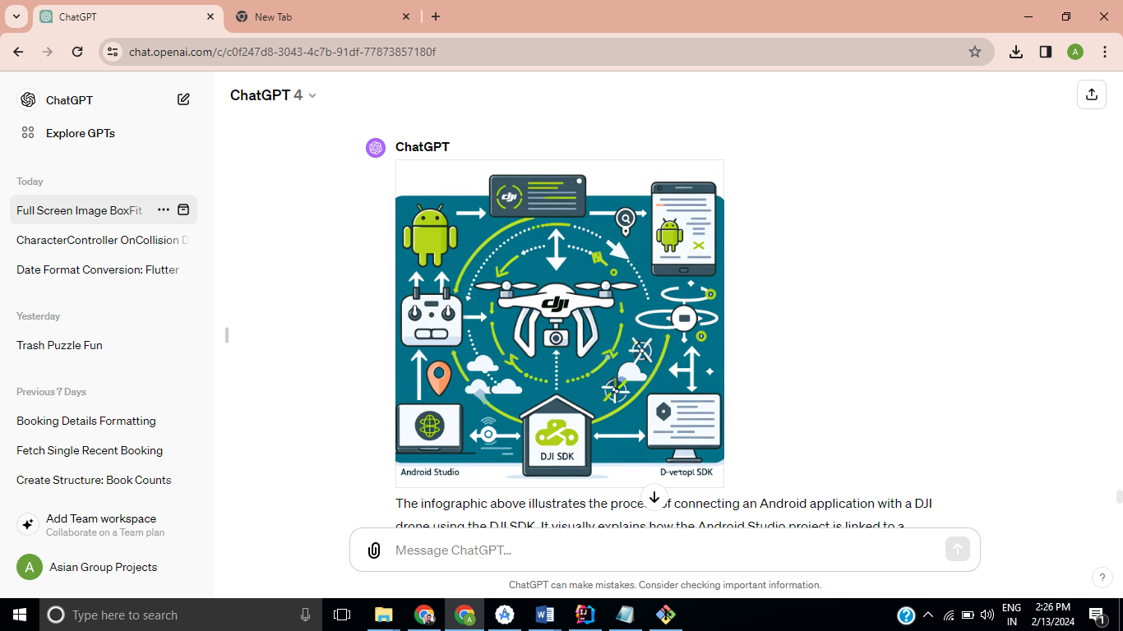

* **Developer Account on DJI Developer Portal**: You start by creating a developer account on the DJI Developer portal, which allows you to obtain an App Key necessary for using the DJI SDK in your application.
* **Android Studio Project**: Within Android Studio, you develop your Android application, integrating the DJI SDK with the help of the App Key acquired from your developer account.
* **DJI SDK Integration**: The DJI SDK facilitates communication between your Android app and the DJI drone. It provides the necessary tools and APIs for controlling the drone, accessing its telemetry data, and performing other operations like taking photos or videos.
* **API Server Communication**: Your application can send and receive data to/from an API server. This might include uploading telemetry data, downloading flight paths, or any other information relevant to your app's functionality.
* **Drone Connectivity**: The core of this setup is the connectivity between your Android app and the DJI drone through the DJI SDK, enabling direct control over the drone and access to its data and sensors.

DJI drones offer extensive capabilities when integrated with mobile apps through the DJI SDK. The SDK provides developers with tools to build custom applications that can control the drone, access its sensors, and use its various functionalities. Here's an overview of the facilities and features you can leverage in a mobile app for DJI drones:

**1. Flight Control**

* **Automated Flight Paths**: Program drones to fly specific routes using waypoints or predefined patterns.
* **Virtual Joystick**: Control the drone's movement in real-time with a virtual joystick interface.
* **Gesture Control**: Implement gesture-based commands for taking photos, starting/stopping video recording, and controlling flight paths.

**2. Camera and Gimbal Control**

* **Live Video Feed**: Access the drone's camera feed in real-time for live streaming or monitoring purposes.
* **Camera Settings**: Adjust camera settings like ISO, shutter speed, aperture, and white balance directly from the app.
* **Gimbal Control**: Programmatic control over the gimbal's pitch, roll, and yaw for stable and precise camera movements.

**3. Telemetry Data Access**

* **Real-Time Data**: Access real-time flight telemetry, including altitude, speed, distance, and GPS location.
* **Battery Monitoring**: Monitor the drone's battery status to ensure safe flight durations and plan for landings.
* **Signal Strength**: Check the signal strength between the drone and the remote controller or mobile device.

**4. Advanced Features**

* **Obstacle Detection and Avoidance**: Utilize the drone's built-in sensors to detect and avoid obstacles automatically.
* **Geofencing**: Implement geofencing to restrict the drone's flight area for safety and regulatory compliance.
* **Payload Control**: Control and manage additional payloads, such as external cameras, sensors, or delivery mechanisms.

**5. Safety Features**

* **Return to Home (RTH)**: Automatically return the drone to a home point if the battery is low or the signal is lost.
* **Flight Logs**: Keep detailed logs of each flight, including route, duration, and any incidents, for analysis and compliance.
* **Emergency Landing**: Implement emergency landing procedures that can be triggered manually or automatically under certain conditions.

**6. Custom User Interfaces**

* **Custom Flight Data Dashboard**: Create custom interfaces to display flight data and controls tailored to specific use cases.
* **Integration with Maps and GIS Data**: Integrate with mapping services for planning flights, setting waypoints, and monitoring flights in real-time.

**Integration Examples**

Developers have used the DJI SDK to create a wide range of applications, from agricultural and industrial inspection apps to photography, videography, and entertainment apps. The flexibility of the SDK allows for creative and innovative uses beyond traditional drone operations.

**Getting Started**

To start developing with the DJI SDK, you'll need to:

* Sign up for a DJI Developer account.
* Create an app in the DJI Developer portal to get an App Key.
* Download the DJI SDK and integrate it into your mobile app project.

DJI provides extensive documentation and sample code to help developers understand and use th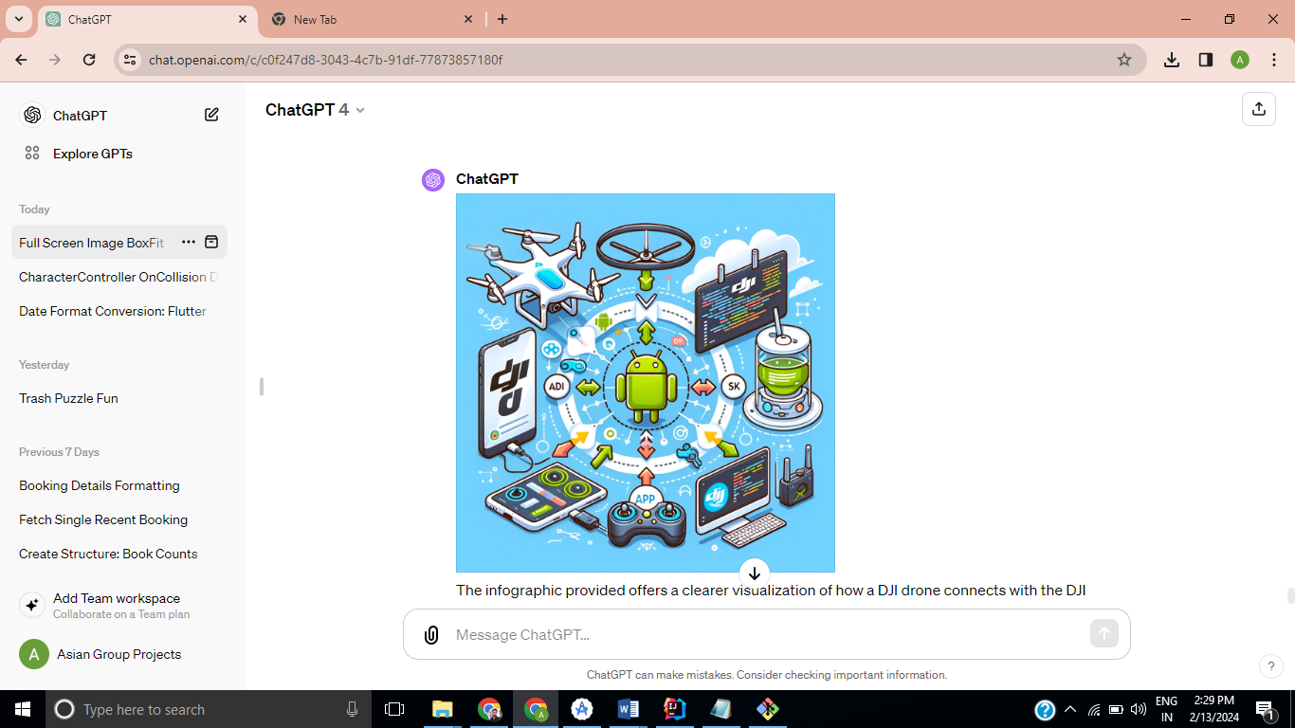

e SDK's features effectively.

**1. Waypoint Information**

* **Latitude and Longitude**: The geographic coordinates of each waypoint.
* **Altitude**: The altitude for the drone at each waypoint.
* **Speed**: The desired speed of the drone when moving towards this waypoint.
* **Action**: Any specific actions (like take a photo, start/stop recording, etc.) to be performed at each waypoint.

**2. Flight Parameters**

* **Flight Path Type**: Determines whether the flight path between waypoints is straight or curved.
* **Curve Size** (if applicable): If using curved paths, this defines the curvature radius between waypoints.
* **Pause Duration**: Time to hover at each waypoint before proceeding to the next one.

**3. Drone Configuration**

* **Battery Level**: Simulated battery level to test flight path feasibility.
* **Payload Weight**: The weight of any payload being carried, as it affects flight dynamics.
* **Drone Model**: Different drone models may have different capabilities or restrictions.

**4. Simulation Settings**

* **Wind Speed and Direction**: To simulate how wind affects the drone's flight.
* **Fail-safes**: Simulated responses to failures like low battery, loss of GPS signal, or communication loss.
* **Geofencing Limits**: To simulate the drone's response to restricted areas.

**5. Environmental Conditions**

* **Weather Conditions**: Like rain, fog, which might affect visibility and drone performance.
* **Time of Day**: To simulate different lighting conditions, which might be relevant for camera operations.

**Example JSON Request for a Waypoint Simulation**

jsonCopy code

{ "simulationName": "Test Flight 1", "droneModel": "DJI Mavic Air 2", "waypoints": [ { "latitude": 40.7128, "longitude": -74.0060, "altitude": 30, "speed": 5, "action": "takePhoto", "pauseDuration": 2 }, // Additional waypoints... ], "flightPathType": "straight", "droneConfiguration": { "batteryLevel": 90, "payloadWeight": 0.5 }, "simulationSettings": { "windSpeed": 5, "windDirection": 90, "failSafes": { "lowBattery": "returnHome", "lossOfGPS": "hover" }, "geofencingLimits": { "enabled": true, "boundary": [ // Define geofencing boundary... ] } }, "environmentalConditions": { "weatherConditions": "clear", "timeOfDay": "14:00" } }

{

"simulationName": "Test Flight 1",

"droneModel": "DJI Mavic Air 2",

"waypoints": [

{

"latitude": 40.7128,

"longitude": -74.0060,

"altitude": 30,

"speed": 5,

"action": "takePhoto",

"pauseDuration": 2

},

// Additional waypoints...

],

"flightPathType": "straight",

"droneConfiguration": {

"batteryLevel": 90,

"payloadWeight": 0.5

},

"simulationSettings": {

"windSpeed": 5,

"windDirection": 90,

"failSafes": {

"lowBattery": "returnHome",

"lossOfGPS": "hover"

},

"geofencingLimits": {

"enabled": true,

"boundary": [

// Define geofencing boundary...

]

}

},

"environmentalConditions": {

"weatherConditions": "clear",

"timeOfDay": "14:00"

}

}

### MAVLink and Drones

MAVLink facilitates communication for tasks such as commanding flights (start, stop, waypoint navigation), transmitting the real-time status of the drone (position, velocity, battery status, GPS health), and controlling camera and gimbal parameters. It's an essential part of drone operation, enabling not just basic flight control but also advanced operational capabilities like autonomous flight, obstacle avoidance, and payload management.

**Key Features of MAVLink**

* **Lightweight and Efficient**: Optimized for bandwidth and processing power, making it suitable for small microcontrollers and limited bandwidth telemetry.
* **Extensible**: Supports custom messages, allowing developers to extend functionality for specific use cases without altering the core protocol.
* **Cross-Platform**: Can be used on various platforms and supports multiple programming languages, making it versatile for different drone systems and ground control software.
* **Reliable**: Implements sequence numbers and CRC checks to ensure the integrity and reliability of message transmission.

**MAVLink and DJI Drones**

While DJI drones primarily use their proprietary protocols and SDKs for communication and control, there are ways to integrate MAVLink-compatible systems with DJI drones for specific applications. This typically involves using onboard computers or third-party modules that can translate MAVLink commands to DJI's protocol or vice versa. For instance, developers might use a Raspberry Pi or similar microcontroller running a MAVLink-compatible autopilot software alongside a DJI drone to achieve a hybrid system that benefits from both MAVLink's open standards and DJI's advanced drone capabilities.

**Use Cases**

* **Autonomous Missions**: Plan and execute complex flight patterns and missions autonomously using waypoint navigation.
* **Telemetry and Monitoring**: Real-time monitoring of flight status, battery levels, and sensor data for safety and operational efficiency.
* **Payload Control**: Control cameras, sensors, and other payloads using MAVLink messages for tasks like mapping, inspection, and surveillance.

**Conclusion**

MAVLink plays a crucial role in the broader ecosystem of drone technologies, providing a standardized way to communicate with and control UAVs across different platforms. While DJI has its ecosystem and protocols, the adaptability of MAVLink allows for integration into a wide range of projects, combining the strengths of both MAVLink's open standards and DJI's advanced drone technologies for innovative applications.

